Installing Python (IDLE)

1. Get the Python 3.8 application from the Microsoft Store

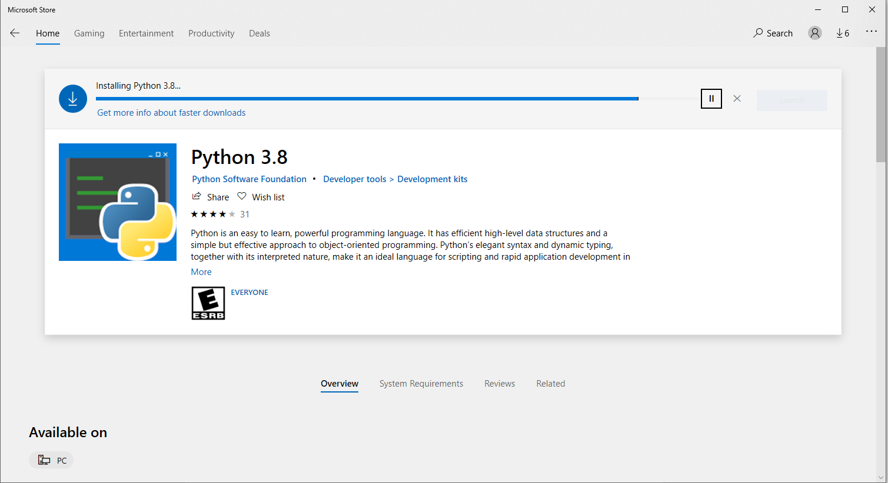

1. Create a new folder for Python Scripts anywhere (I have mine in “Documents”)

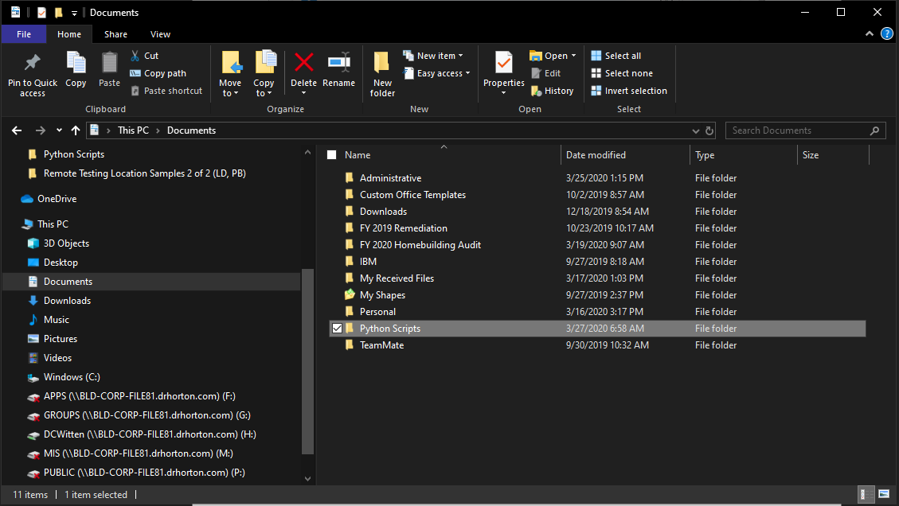

1. Drill into folder and type “cmd” on the browser line

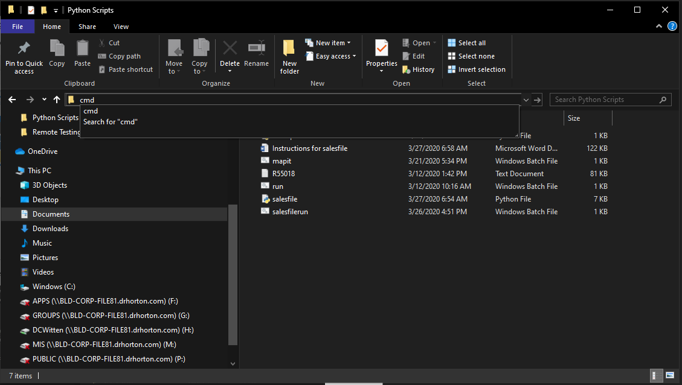

1. On the command prompt type “pip install pandas” and follow any instructions

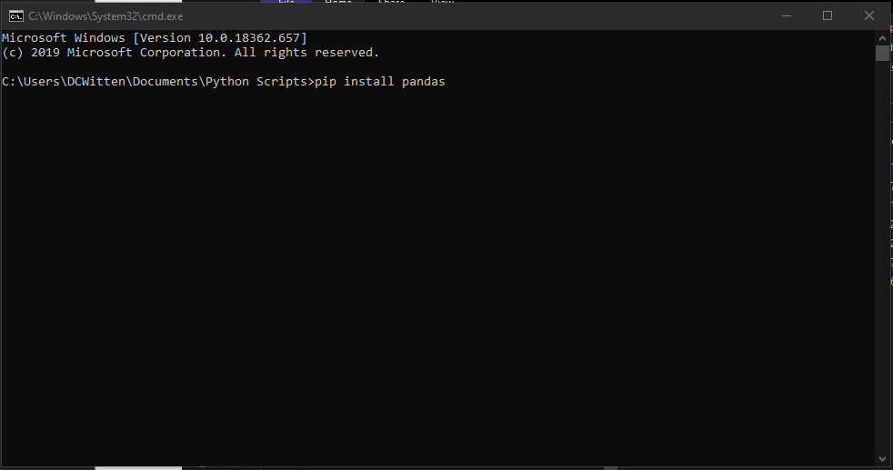

1. Once complete type “pip install openpyxl” and follow any instructions

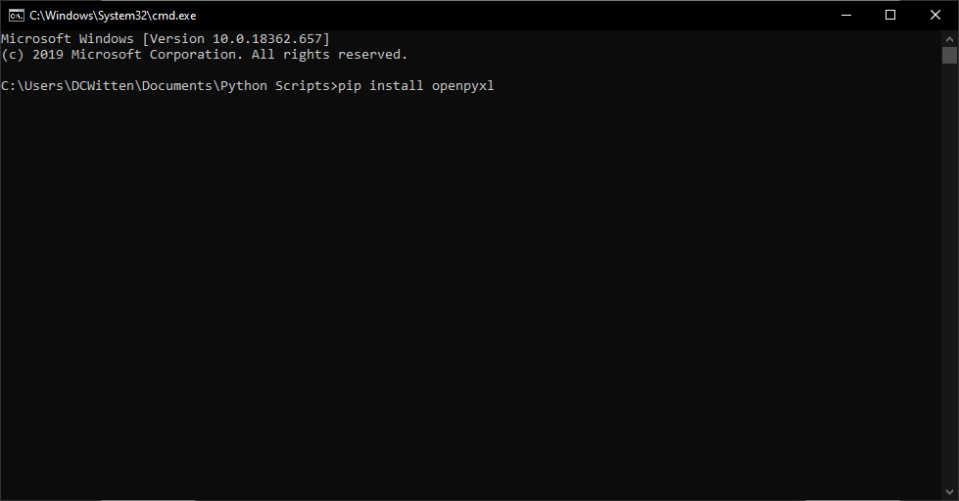

Running the Sales Files Script

1. Place the salesfile.py and the salesfilerun.bat files in your Python Scripts folder

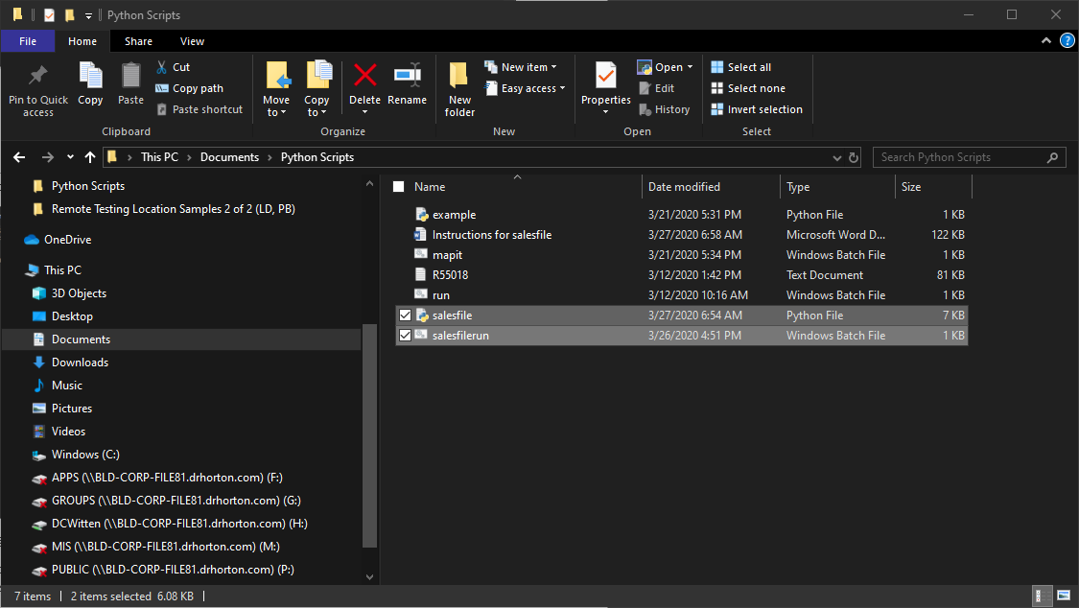

1. For ease of use, place the sales file text in the same folder as the script (optional)
2. Double click on salesfilerun.bat to run the script and answer command line prompts. Enjoy!